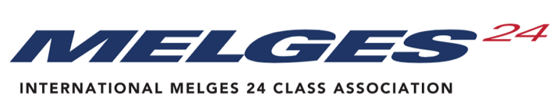
EXTRAORDINARY GENERAL MEETING 2025
Wednesday, 8 October 2025
According to the IM24CA Constitution, motions, amendments, and nominations for the AGM shall be proposed only by the Executive Committee, NCA’s, the Technical Committee, and World Sailing and must reach the International Secretary not less than eight (8) weeks before the official announced date of the meeting. Only the motions, amendments, and nominations on the Agenda and its attachment/s shall be voted upon. In exceptional circumstances, the Chairman may accept amendments from the floor of the AGM when, in his opinion, this will assist in resolving issues on which the World Council has had an opportunity to express its views.
The deadline for the submissions for the 2025 October EGM is September 10, 2025. To allow this process to function smoothly, each Submission should adhere to the following guidelines:
- The Submission shall clearly state the current position, the proposal for a change (clearly stating the rule), and the rationale behind this change.
- The Submission should be written to relate to any IM24CA documents or topics, as listed below.
- Wherever possible, each submission should contain wording for the proposed new rules.
- Reason for the motion
- Technical items that the tech staff can work on during the year should not be sent as a Submission
Nominating Body
Exec Comm, NCA, Tech Comm

Name and Surname
Position in Nominating
Body

E-mail
Title of the motion,
amendment, nomination

Topics concerned
 | Constitution |  | Events
 | Class Rules |  | Technical issues
 | Regatta Regulations |  | General policies
 | Nomination
Proposal
You can widen
this box if
needed

Reason

