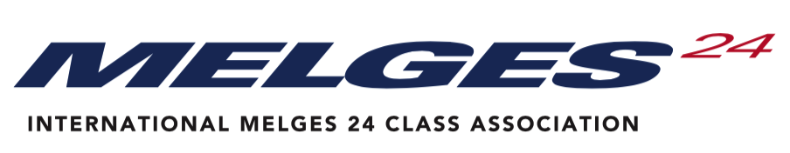

WORLD COUNCIL ANNUAL GENERAL MEETING 2022

VOTING PROXY ASSIGNMENT FORM

On behalf of the  Please write the country you are representing | ………………………………………………………  Melges 24 Class Association
I formally advise the IM24CA World Council that for the Annual General Meeting of the Class taking place on | 19 November 2022 – in Zoom
The following individual will represent our national class.
Please write the name of the person who will represent your country
Please ensure that this individual receives copies of all relevant meeting correspondence via the following contacts
Please write the e-mail of representative
Signed by the National Class President
Please write your name
Signed by the Executive Officer
(please state post held)
Please write Executive Officer name
Date of Proxy

Note – Your proxy may be from any other National Class of your choice but they must be a full (owner) member of the Melges 24 Class in good standing. A member National Class Association may not vote for more than two (2) proxies.

Please note here your National Class’ positions on certain submissions on the Agenda:
Rule Change Proposals from National Classes:  - USA 1 - POV (Point of View) Camera - Rev 1  - USA 2 - Weed Sticks - Rev 1  - ITA 1 - CREW WHEN HIKING - with Tech Comm comments  - ITA 2 - CREW INSIDE COMPANIONWAY | - ____ In favor ____ Not in favor ____ Abstain  - ____ In favor ____ Not in favor ____ Abstain  - ____ In favor ____ Not in favor ____ Abstain  - ____ In favor ____ Not in favor ____ Abstain
Rule Change Proposals from Technical Committee:  - 2022 Rule Change C.7.1 HULL MODIFICATION, MAINTENANCE AND REPAIR Rev 1  - 2022 Rule Change C.7.2 (a)(11) USE Rev 1  - 2022 Rule Change C.8.1 MODIFICATIONS, MAINTENANCE AND REPAIR Rev 2  - 2022 Rule Change C.8.2 KEEL 2019 Cdn Rev6 2022  - 2022 Rule Change D.2.3 MODIFICATION, MAINTENANCE AND REPAIR Rev 2  - 2022 Rule Change E.2.2 MODIFICATIONS, MAINTENANCE AND REPAIR Rev 2  - 2022 Rule Change H4 Boat and Appendage Repair Approval Form Rev 2  - 2022 Rule Change Proposal H2 Cabin Main Halyard Rev 2  - 2022 Rule Change Proposal H2 Purchase Systems Bowsprit Launch Rev 1 | - ____ In favor ____ Not in favor ____ Abstain  - ____ In favor ____ Not in favor ____ Abstain  - ____ In favor ____ Not in favor ____ Abstain  - ____ In favor ____ Not in favor ____ Abstain  - ____ In favor ____ Not in favor ____ Abstain  - ____ In favor ____ Not in favor ____ Abstain  - ____ In favor ____ Not in favor ____ Abstain  - ____ In favor ____ Not in favor ____ Abstain  - ____ In favor ____ Not in favor ____ Abstain
Elections – Nominations  Executive Committee  - Chairman – Laura Grondin, USA  - Vice Chair Asia Pacific – Kevin Nixon, AUS  - Vice Chair Americas – Chelsea Simms, USA  - Member North Americas – Scot Zimmerman, USA  - Member Europe – Michael Tarabochia, GER  Other positions  - Technical Committee Chair – Mike Gozzard, CAN  - Championship Coordinator for North Americas – Carol Ewing, USA | Executive Committee  - ____ In favor ____ Not in favor ____ Abstain  - ____ In favor ____ Not in favor ____ Abstain  - ____ In favor ____ Not in favor ____ Abstain  - ____ In favor ____ Not in favor ____ Abstain  - ____ In favor ____ Not in favor ____ Abstain  Other positions  - ____ In favor ____ Not in favor ____ Abstain  - ____ In favor ____ Not in favor ____ Abstain
Future Events, proposals & decisions

Any Other Business

