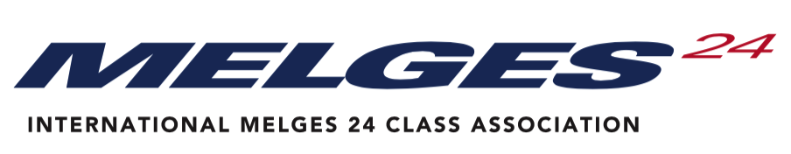

WORLD COUNCIL ANNUAL GENERAL MEETING 2020

VOTING PROXY ASSIGNMENT FORM

On behalf of the  Please write the country you are representing | ………………………………………………………  Melges 24 Class Association
I formally advise the IM24CA World Council that for the Annual General Meeting of the Class taking place on | 07 November 2020 – virtually in Zoom
The following individual will represent our national class.
Please write the name of the person who will represent your country
Please ensure that this individual receives copies of all relevant meeting correspondence via the following contacts
Please write the e-mail of representative
Signed by the National Class President
Please write your name
Signed by the Executive Officer
(please state post held)
Please write Executive Officer name
Date of Proxy

Note – Your proxy may be from any other National Class of your choice but they must be a full (owner) member of the Melges 24 Class in good standing. A member National Class Association may not vote for more than two (2) proxies.

Please note here your National Class’ positions on certain submissions on the Agenda:
- National Class Association Submissions

- Proposed Class Rule Changes

- Proposed changes to Class Constitution

- Future Events, proposals & decisions

- Any Other Business

