PLEASE NOTE

This pro-former is to be used by National Melges 24 Class
Associations who issue their own certificates and is available to any
National Authority that wishes to use it.

The certificate number should be formatted as follows:

09FRA-438A

(09 is the year of issue,
FRA is the issuing National Authority,
438 is the hull number,
A is the edition of the certificate for this boat)

IT IS ONLY VALID WHEN IT IS STAMPED WITH EITHER A
NUMBERED MELGES 24 CLASS CERTIFICATE STAMP (The stamp
must be the number allocated to that National Association) OR THE
STAMP OF THE NATIONAL AUTHORITY.

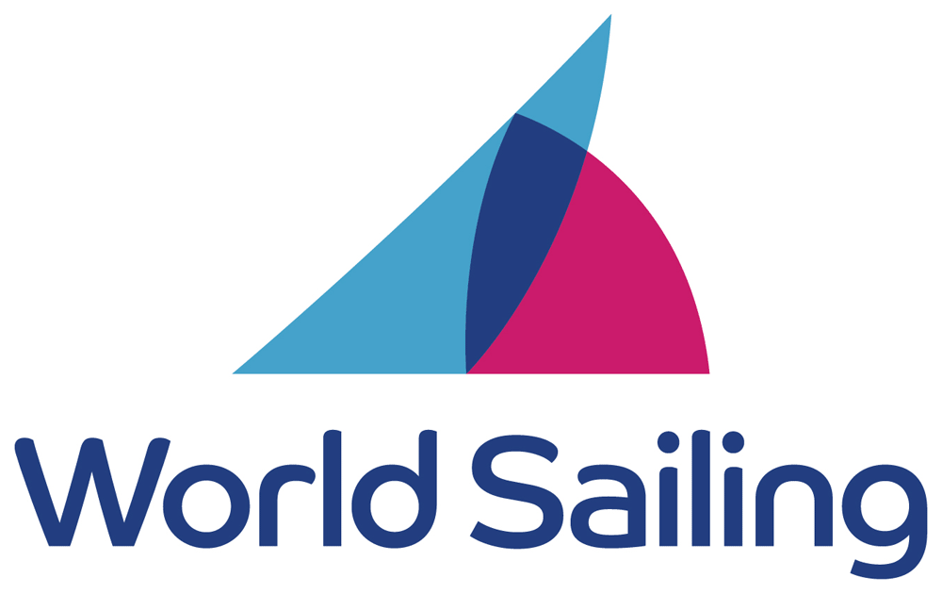

Insert logo Insert logo
International Authority Member National Authority National Class Association

- INTERNATIONAL MEASUREMENT CERTIFICATE –
( As required per RRS 78)
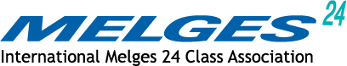

Boat Name:

Sail N°: Owner:

Builder: Address:

Hull ID N°:

- C e r t i f i c a t e b a s e d o n M e a s u r e m e n t F o r m d a t e d :
- First Measurement completed:
Keel Weight: Corrector Weights at first measurement:
by:
kg. Keel serial number: kg

- Last Measurement completed: |  | by:
Complete Boat Weight inc Correctors:  Corrector Weights: | kg  kg

Certificate Number: Date of this Certificate:

Certificate authorised by: acting for the
Email :

Owner’s Declaration
I undertake to race this Melges 24 only so far as I maintain it to conform with the International Melges 24 Class Rules. I also undertake that corrector weights (if any) will not be altered or removed except when carried out in conjunction with an official re-weighing undertaken by an approved Melges Class Measurer. At such time or upon a change of to any of the details shown on this certificate I will return it to my Revalidation Authority.

Owners Signature : Date:

- T o b e v a l i d t h i s c e r t i f i c a t e n e e d s t o b e s i g n e d b y t h e o w n e r . –

