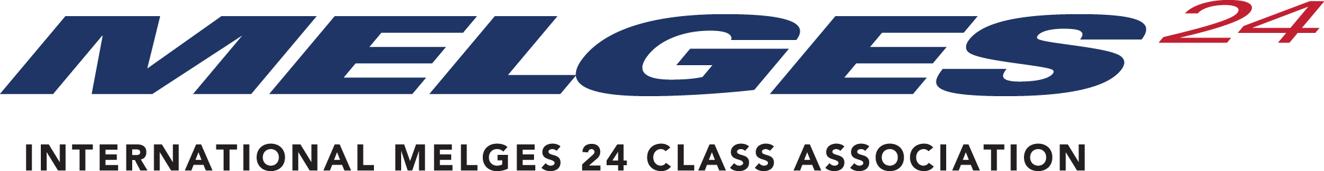

Boat and Appendage Repair Approval Form

Before commencing work, all repair work shall be approved by the IM24CA Technical Committee Chair or Class Chief Measurer.

Pictures and a complete description of the work shall be provided. Photos of the repair process shall be provided and submitted for sign-off upon completion before the boat is approved for One Design Racing. Pictures and descriptions may be placed in the Boat Repair section on the class website.

Owner______________________________________________________________________

Date_______________________ HIN Number______________________________________

Sail Number_________________

Description of Damage:
___________________________________________________________________________
___________________________________________________________________________
___________________________________________________________________________
___________________________________________________________________________

Name of Shop (or individuals) Responsible for Effecting the Repair:
___________________________________________________________________________
___________________________________________________________________________
___________________________________________________________________________
___________________________________________________________________________

Proposed Repair Process:
___________________________________________________________________________
___________________________________________________________________________
___________________________________________________________________________
___________________________________________________________________________

Pictures Attached – list the number of pictures here _____________

Approval from Class Representative _______________________________________________

PLEASE RETURN THIS COMPLETED FORM WITH PICTURES TO:
International Melges 24 Class Association
Class Administrator - Email: piret@melges24.com

