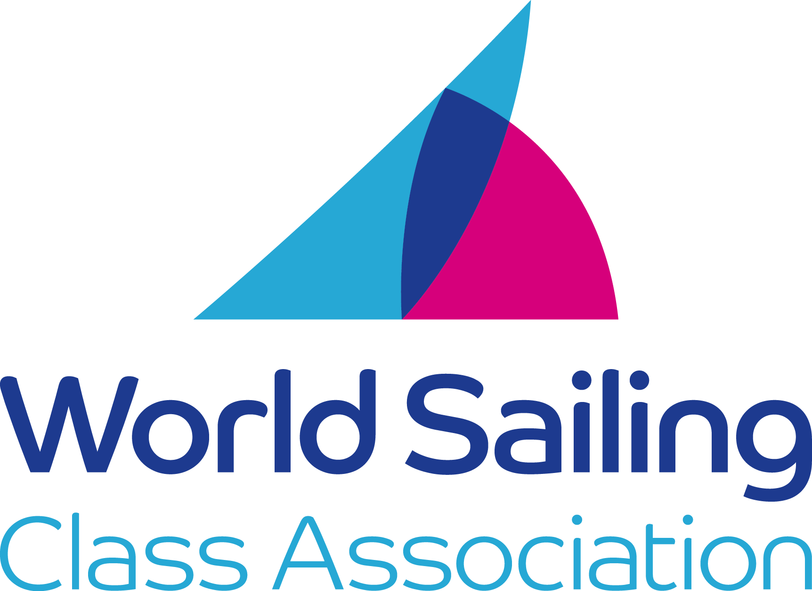
2021
International Melges 24 Class
Measurement Form

Authority*: World Sailing.
20 Eastbourne Terrace, Paddington, London, W2 6LG, United Kingdom.
*TheWorld Sailing is not a Member National Authority (MNA).

Boat Details
National Letters …………………………………………………
Sail Number/ICA Plaque Number …………………………………………………
Name of Boat …………………………………………………
EU Craft Identification Number (CIN) …………………………………………………
Serial Number of Keel Fin …………………………………………………
Owners Name …………………………………………………………………….…
Owners Address ……………………………………………………………………..…
………………………………………………………………………………………………
Weight of boat including any correctors ……………….. kg
Weight of Correctors ……………….. kg
The original of this form must be submitted to the boat's National Authority or National Class Association if they
have been appointed by the MNA, for a full measurement certificate to be issued.

OWNERS DECLARATION
I undertake to race this International Melges 24 only so long as I maintain it in conformity with the Class Rules.
I also undertake that corrector weights (if any) will not be altered or removed except when carried out in conjunction with an official re-weighing by an approved International Melges 24
Class Measurer, and that only spars, sails etc., which have been measured and found in accordance with the rules, will be used.

Signature........................................................... Date......................................................

 | Rule | Measurement | Min | Actual | Max
1 | E.3.6 | Combined keel fin and bulb weight. | 300kg |  | 313kg
2 | H.2 mast step | Forward edge of mast step from aft face of furler drum recess. | 2405mm |  | 2415mm
3 | D.6 | Are deck fittings in the prescribed places? | ------- | Yes/No
4 | C.8.2 | HDP to intersection of fin trailing edge and hull. | 3482mm |  | 3494mm
5 | C.8.2 | HDP to intersection of bulb top and fin aft edge. | 3784mm |  | 3823mm
6 | C.8.2 | Underside of hull to top of bulb. | 1195mm |  | 1215mm
7 | C.8.3 | HDP to trailing edge rudder tip | ------- |  | 1220mm
8 | C.8.3 | Rudder head parallel to transom +/- 2mm | ------- | Yes/No | -------
9 | E.3.5 & E.4.5 | Do rudder, fin and bulb fit templates? | ------- | Yes/No | -------
10 | E.4.6 | Assembled weight rudder | 9,3kg
11 | E.4.7 | Rudder corrector weights if any (kg) | ------- |  | -------
12 | C.9.5 | Bowsprit extension. | ------- |  | 1400mm
11 | F.3.5 | Weight of complete mast with all rigging. | 28 kg |  | -------
12 | F.3.5 | Tip weight of mast. | 10 kg |  | -------
13 | F.3.4. | MHP to Lower mast point. | 710mm |  | -------
14 | F.3.4. | MHP to upper mast point. | ------- |  | 9528mm
15 | F.3 | Does mast and rigging comply with all other requirements of the rules? | ------- | Yes/No | -------
16 | C.9.4 | Boom band distance from aft edge of the mast. | ------- |  | 3800mm

MEASURERS DECLARATION
I certify that I have taken the measurements on this form and that to the best of my knowledge
the boat conforms to all of the rules and specifications at present in force of the International
Melges 24 Class except as I have stated below.
Comments …………………………………………………………………………………
………………………………………………………………………………………………….
Name ……………………………………….. Date …………..………………
Address …………………………………………………………………………………
Signature …………………………………………………………………………………
N.B. Boats may be measured by an In House Certification (IHC) process, but shall be checked at regular intervals by an independent Melges 24 Class Measurer. If IHC is used, the above shall be filled in by the builder and written so across the Measurers Declaration.

BUILDERS DECLARATION
I certify that this Melges 24 has been built and completed to the rules and specifications of the
International Melges 24 Class and the copyright Holder and any fees paid.

Name of Builder …………………………………………………………………………
Signature ……………………………… Date …………………………

